 AUTOMATED MONITORING SYSTEM 

A PROJECT REPORT
Submitted by

SAURABH K P (080105105051)
VENKATESH P (080105105057)
ZUNITH AHMED C L (080105105060)

in partial fulfilment for the award of the degree
of

BACHELOR OF ENGINEERING
in
COMPUTER SCIENCE AND ENGINEERING

DR.N.G.P INSTITUTE OF TECHNOLOGY, COIMBATORE
ANNA UNIVERSITY OF TECHNOLOGY
COIMBATORE 641048

MARCH 2012

ANNA UNIVERSITY OF TECHNOLOGY
COIMBATORE 641047

BONAFIDE CERTIFICATE

Certified that this project report “AUTOMATED MONITORING SYSTEM” is the bonafide work of “SAURABH K P (080105105051), VENKATESH P (0801050105057), ZUNITH AHMED C L (080105105060)” who carried out the project work under my supervision.

SUPERVISOR HEAD OF THE DEPARTMENT
MRS.SASHI REKHA K S DR. MOHAN.S
ASSISTANT PROFESSOR PROFESSOR
Computer Science and Engineering Computer Science and Engineering
Dr.N.G.P Institute of Technology Dr.N.G.P Institute of Technology
Kalapatti Road, Cbe- 48. Kalapatti Road, Cbe-48.

------------------------------- -------------------------------
Internal Examiner External Examiner

TABLE OF CONTENTS

CHAPTER No. TITLE PAGE No.
ABSTRACT
LIST OF TABLES
LIST OF FIGURES
LIST OF ABBREVATIONS

- INTRODUCTION

  - Objective

- SYSTEM ANALYSIS

  - Existing System
2.1.1 Drawbacks
  - Proposed System
  - Feasibility Study
2.3.1 Economic Feasibility
2.3.2 Operational Feasibility
    - Technical Feasibility

- SYSTEM SECIFICATION

  - Hardware Requirements
  - Software Requirements

- SYSTEM DESCRIPTION

- PROJECT DESCRIPTION

  - Problem Definition
  - Overview of the project
  - Module Description
5.3.1 Modules
  - Data Flow Diagram
  - ER Diagram
  - Database Design
  - Input Design
  - Output Design

- SYSTEM TESTING

  - Unit Testing
  - Integration Testing
  - White Box Testing
  - Black Box Testing
  - Validation Testing
  - Software Testing
  - Performance Testing

- SYSTEM IMPLEMENTATION

- CONCLUSION AND FUTURE ENHANCEMENTS

  - Conclusion
  - Future Enhancements

- APPENDIX

  - Source Code
  - Screen Shots

- RFERENCES

ABSTRACT
The main objective of the Automated Monitoring System (AMS) is to simplify the task of the Administrator so as to get the immediate access on the daily basis to the (Digital Video Recording) DVR facility.
Currently the system is completely dependent on DVR software. This software recommends high technical ability of the user to access the system. The user needs to own a sound knowledge about the DVR and the concerned software so as to use it.
This can be easily overcome by the Automated Monitoring System (AMS). This system can be easily handled by users with the basic knowledge about the internet. The administrator has the supreme authentication who can not only himself access the AMS but also provide privileges to other users so as to access the AMS from anywhere in the campus using LAN.

LIST OF TABLES

TABLE NO TITLE PAGE NO

1 System Description 17

2 Upload Video 18

3 Update System Monitoring 18

4 Student Details 18

5 Non-Teaching Staff Details 19

6 Teaching Staff Details 19

7 Login database design 31

8 Non teaching Staff detail database 32
design

9 student detail database design 33

10 System Monitoring database design 33

11 Teaching Staff Detail 33

12 Time tables 34

13 Video 34

LIST OF FIGURES

FIGURE NO TITLE PAGE NO

1 DVR 20

2 TY4213-D Camera 20

3 Connectivity between DVR 21
and TY4213-D

4 Data Flow Diagram Level0 24

5 Data Flow Diagram Level1 25

6 E R Diagram 26

LIST OF ABBREVATIONS

- DVR- Digital Video Recording

- AMS- Automated Monitoring System

- CCTV- Close Circuit Tele Vision

- PSS-Pro Surveillance System

- IP- Internet Protocol

- LAN- Local Area Network

- DFD- Data Flow Diagram

CHAPTER 1
INTRODUCTION

  - OBJECTIVE
The main objective of the Automated Monitoring System (AMS) is to simplify the task of the Administrator so as to get the immediate access on the daily basis to the (Digital Video Recording) DVR facility.
Currently the system is completely dependent on DVR software. This software recommends high technical ability of the user to access the system. The user needs to own a sound knowledge about the DVR and the concerned software so as to use it.
This can be easily overcome by the Automated Monitoring System (AMS). This system can be easily handled by users with the basic knowledge about the internet. The administrator has the supreme authentication who can not only access the AMS but also provide privileges to other users so as to access the AMS from anywhere in the campus using LAN.

CHAPTER 2
SYSTEM ANALYSIS
  - EXISTING SYSTEM
Existing system consists of the DVR and the ‘WEB SERVICES’ software. This combination works well with the experienced professionals. This system consists of facility of handling multiple CCTV cameras. Based on the DVR IP address the connections are made between the DVR and the server. Through this server the DVR contents are viewed.
    - Drawbacks
Meanwhile when the system needs to be accessed by someone who does not have enough knowledge regarding the Digital Video Recording and the software related to DVR, it becomes too complicated to have the facility of the DVR.

  - PROPOSED SYSTEM
Automated Monitoring System (AMS) serves as a comfort zone for the new users who are unfamiliar with the DVR handling. The system provides an easy and much user friendly environment so as to access the specified content. This proposed system (as designed to be implemented in the college premises) consists of a subject schedule for the respective hall or laboratory that is to be monitored. The videos present in the DVR can be easily viewed on the basis of user’s choice, based on the respective links to the DVR recordings so as to view it. The corresponding staff and students lists are also automated for each session. The system also provides LIVE viewing of the specified location and also the individual system can monitored based on the additional softwares attached with the proposed system.

  - FEASIBILITY STUDY
Feasibility analysis is the procedure for identifying the candidate system, evaluating and selecting the most feasible system. This is done by investigating the existing system in the area under investigation or generally ideas about a new system. Feasibility Study is used to verify whether the system is fit to be developed in all terms. It is a test of a system proposal according to its working ability, impact on the organization, ability to meet user needs, and effective use of resources. A feasibility study is not warranted for systems in which economic justification is obvious, technical risk is low, few legal problems are expected and no reasonable alternative exists. This study will decide whether this system is cost effective from the business point of view and if it can be developed in the given existing budgetary constraints. The feasibility study is not to solve the problem but to acquire a sense to its scope.

Feasibility analysis involves 8 steps.
- Form a project team and appoint a project leader.
- Prepare system flow chart.
- Enumerate a potential candidate system.
- Describe and identifying characteristics of candidate system.
- Determine and evaluate performance and cost effectiveness of each candidate system.
- Weigh system performance and cost data.
- Select the best candidate system.
- Repair and report final project directive to management.

There are three aspects in the feasibility study portion of the primary investigation.
- Economic Feasibility
- Operational Feasibility
- Technical Feasibility

The proposed system must be evaluated from the technical point of view first, and if technically feasible their impact on the organization must be accessed. If compatible, operational system can be devised. Then they must be tested for economic feasibility
    - Economic Feasibility
Economic analysis is the most frequently used for evaluating the effectiveness of a candidate system. It is more commonly known as cost benefit analysis, the procedure to determine the benefits and savings that are expected from a candidate system and compare them with costs. The developing system must be justified by cost and benefit. One of the factors, which affect the development of new system, is the cost it would require. Since the system developed is a part of the project work, there is no manual cost to spend for the proposed system. Also all the resources are already available, giving an indication that the system is economically possible for development. If the benefits outweigh costs then a decision is made to design and implement the system. Otherwise make alternation in the proposed system.

    - Operational Feasibility
Proposed projects are beneficial only if they can be turned into information systems that will meet the organization’s operating requirements. Simply there is no difficulty in implementing the system if the user has the knowledge of internal working. The whole operation does not require expert computer knowledge. The purpose of the operational feasibility study is to determine whether the new system will be used if it is to be developed and implemented and whether there will be resistance from the users who will undermine the possible application benefits. There was no difficulty in implementing the system and the proposed system if so effective, user friendly and functionally reliable that the users in the organization will find the new system reduces their hardships. If the users of the system are fully aware of the internal working of the system, then the users will not be facing any problem running the system.
Questions that will to test the operational feasibility of the project are:
- Is there sufficient from the management?
- Are current business methods acceptable to the users?
- Have the users been involved in the planning and development of the project?
- Will the proposed system cause harm?

    - Technical Feasibility
Three key considerations are involved in the feasibility analysis: Economic, Technical and Behavioural. The assessments of technical feasibility centres in the existing system and to what extent it can support to the proposed addition. This was based on an outline design of system requirements in terms of inputs, files, programs, procedures and staff. It involves financial considerations to accommodate technical enhancements. Technical Feasibility deals with the function, performance and the constraints like resource availability, technology and development risk that may affect the ability to achieve an acceptable system.

Facts that are normally associated with technical feasibility include:
- Development Risk
- Resource Availability
- Technology

Technical feasibility study deals with the hardware as well as software requirements. The scope was whether the work for to be examined in the feasibility study. The outcome was found to be positive.

The important modules of this domain:
- Viewing various lab schedules
- Change Password
- Updating schedules, staff details and student details (for lab use)
- Classroom Spy and PSS linking

CHAPTER 3
SYSTEM SPECIFICATION
  - Software Requirements

Operating system : - Windows XP Professional
Front End : - Microsoft Visual Studio .Net 2010
Back End : - SQL Server

  - Hardware Requirements

- SYSTEM : Intel Dual Core
- HARD DISK : 40 GB
- RAM : 1 GB
- Cp-ty-4213-d type camera.
- DVR (Digital Video Recorder)

3.3. Development Environment Requirements

IDE : Dreamweaver CS5
Visual Studio 2010 DOT NET Developer

CHAPTER 4
SYSTEM DESCRIPTION

The Automated Monitoring System deals with the complete automation of the given lab. The system is controlled overall by an administrator. The system provides the list of labs. Now the lab needs to be selected along with the date, using a date picker. The selected date leads to the corresponding lab time table. It is to be noted that the time tables with forenoon and afternoon sessions are provided if and only if the videos have already been uploaded. On that page various options are provided to manipulate the available data. The provided options and their functionalities are mentioned below.
Upload Video | Used for uploading the videos for the concerned date
System Monitoring | Used for updating system monitoring details
Update Student | Used for updating Student details
Update Teaching Staff | Used for updating Teaching staff details
Update Non Teaching Staff | Used for updating Non teaching staff details
Back | Control moves back to the ‘select lab’ page

Each of these contains further constraints that include view details etc. that provide further assistance. The constraints are mentioned below:
Upload Video
Date | Providing the date for which the video is being uploaded. This is done using the method ‘datepicker()’.
Day | The day of week is to be mentioned for which the video is being uploaded.
Class Name | Department and year is to be mentioned
Video Name | This has been provided with a browser, using which we can browse and select the corresponding video to be uploaded.

Update Monitor
Student Name | Name of the student is mentioned.
Roll No. | The Roll No. of the is mentioned.
IP | The IP address for the particular system, that the student uses is mentioned.
Date | Providing the date for which the monitoring details are being uploaded. This is done using the method ‘datepicker()’.

Student Details
Student Name | Name of the student is mentioned.
Roll No. | The Roll No. of the is mentioned.
Dept | Provides the department and year of the student
IP | The IP address for the particular system, that the student uses is mentioned.

Non-Teaching Staff Details
Name | Name of the staff is mentioned.
Designation | Provides the designation of the staff.
Specialist | Provides the specialization field of the staff.

Teaching Staff Details
Name | Name of the staff is mentioned.
Designation | Provides the designation of the staff.

The above mentioned modules (Upload Video, Update Monitoring, Update student details, Update Non Teaching Staff details, Update Teaching Staff details) also provide the viewing of the existing data, from the database.
The system is also provided with the ‘settings’, which deals with the authentication alterations. This involves the ‘Administrator Password Change’ and the ‘Updating of time table’. The other way to make alteration in time table is by providing the name of subject or lab name, while uploading the videos.
Finally, as the system is setup in the Intranet (LAN), it can also utilize the facility to have access to various computer IP addresses that have been connected over the Intranet to execute a module ‘System monitoring’. The system can provide all the computer screens of which the IP address has been mentioned.

The Automated Monitoring System is accompanied by certain hardware also. They are:
The DVR (Digital Video Recorder)
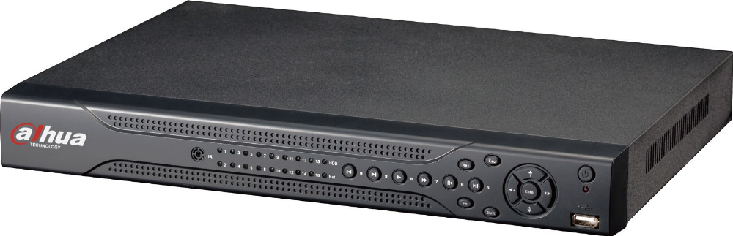

• 16 channel simultaneous playback
• Smart video detection: MD, camera blank, video loss
• 3D intelligent positioning with DAHUA PTZ dome
• Easy backup: USB devices, network downloads
• Alarm triggering screen tips, buzzer, PTZ, e-mail, FTP upload
• Supports 1 SATA HDD, 2 USB2.0
• Built-in web server, multi-DVR client, DMSS & CMS

CCTV Camera
CAMERA (CP-TY4213-D)
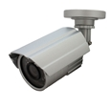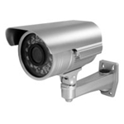

Connectivity between DVR and CCTV (CP-TY4213-D)
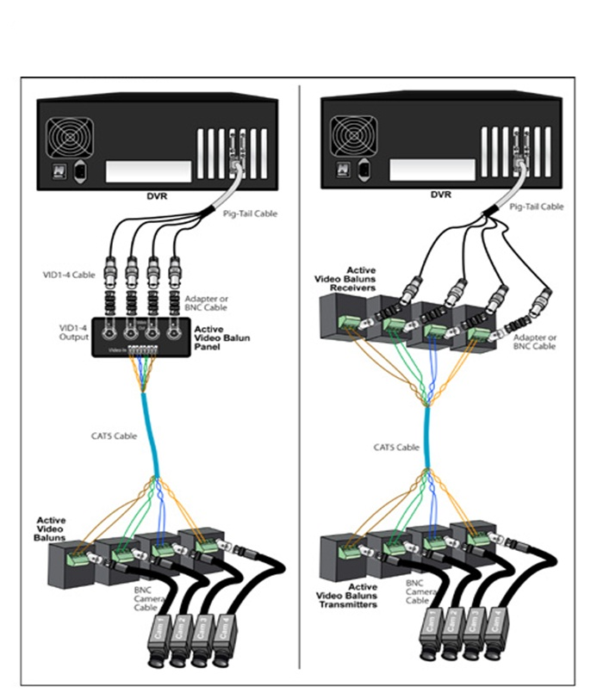

CHAPTER 5
PROJECT DESCRIPTION
  - PROBLEM DEFINITION
The existing system can retrieve and show the recorded as well as LIVE videos from the DVR. But this needs expertise knowledge about the DVR and the corresponding software. Moreover there is no existing system that can provide or synchronize the DVR videos to the corresponding lab time table, along with the staff and student details.

  - OVERVIEW OF THE PROJECT
Automated Monitoring System (AMS) serves as a comfort zone for the new users who are unfamiliar with the DVR handling. The system provides an easy and much user friendly environment so as to access the specified content. This proposed system (as designed to be implemented in the college premises) consists of a subject schedule for the respective hall/laboratory that is to be monitored. The administrator has the complete authentication to access the system. The schedule of any hall can be viewed by the administrator based on the date selected using a calendar. The schedule consists of the respective links to the DVR recordings so as to view it. System also provides assistance to monitor every individual computer in a lab.

  - MODULE DESCRIPTION

LOGIN
Login is done by the administrator for the first time using 'login.htm'. This page has been split into frames for designing purposes. In 'login.htm' the CSS is used with different classes for 'paragraph' tag. Other CSS have also been provided for various 'divisions' represented by <div> tag. The administrator has to enter the 'username' and 'password' in 'login.htm'.
The 'action' from this page is referred to 'login.php'. In 'login.php' the provided 'username' and 'password' are compared with the 'username' and 'password' values present on the 'login' table. If the number of rows with the given 'username' is found to be exactly one and if the corresponding 'password' also matches with the 'password' mentioned in the 'login' table, then the 'select_lab.htm' is called. Else the control goes back to the 'login.htm' with an error message. In 'login.php' the file 'config.inc' has been included so as to link to the database. Session has also been used so as to store the 'username' and 'password' until the user logout.

LAB and DATE selection
When control comes to the 'select_lab.htm', the user is prompted to select the lab, for which the video is to be viewed. The user can select the lab using the provided 'radio' controls. After selecting the lab, the date is also to be mentioned on the same page. The 'date function' is implemented using the java script. The function uses the 'datepicker();' so as to select a date from a calendar control. The calendar control is invoked when the calendar icon is clicked once, placed near the date text box. After selecting the date, click the submit button so as to continue. Then the control moves onto 'select_lab.php'. In the 'select_lab.php' the session is checked. If the 'session['username']' is not set, then the control moves onto the 'login.htm'. Else the control has been diverted in 'select_lab.php' to the corresponding lab time table using an 'if' control statement.

Timetable
The 'Date' value is retrieved from the 'select_lab.htm'. After performing the session check, the control goes to the next page. Based on this value, the corresponding week is displayed with the respective lab time-table in the new page. In the new page the values for corresponding timetable is retrieved. The user can click on the corresponding schedule so as to view the recorded 'DVR video'.

Settings
The 'settings' page includes the 'Password Change' and the 'Update Timetable'.

Password Change:
'Password Change' includes only textboxes. First textbox is used to have the user current password. This password is verified twice. First verification is done with respect to the session value 'session['password']'. Secondly the verification is done with respect to the database table 'login'. If any of these two criteria fails, the changing of password cannot be performed.
Next two textboxes are used for entering the new password and the confirm passwords respectively. If these two textbox contents doesn't match, then the changing of password cannot be performed.

Password Error:
‘Password Error’ is a module that is responsible for the detection of the password errors at the time of password change by the administrator. If the entered password is wrong then the settings page is displayed again. Else the password is changed successfully.

Update Timetable:
In 'update timetables' the current timetable for any lab can be altered by the user (Administrator). The page consists of the time table structure with week days and hours representation (1-7). The user just need to fill the time table on the current page so as to alter the time table. Before submitting the alteration of time table the user is asked to select the lab for which the time table is being altered. After selecting the lab, the user can submit the altered time table.

Non Teaching Staff Details:
The non teaching staff details module deals with the entire manipulation of the details about the concerned staff. The complete storage of the information to the database and retrieval of the same is done using this module for the Non-teaching Staff Details.

Delete Non Teaching Staff Details:
This module helps in deleting the Non teaching Staff details from the database. The system manages many staffs’ details. So as to delete a particular staff detail, a separate icon has been provided, that performs the function of this module.

Teaching Staff Details:
The teaching staff details module deals with the entire manipulation of the details about the concerned staff. The complete storage of the information to the database and retrieval of the same is done using this module for the teaching Staff Details.

Delete Teaching Staff Details:
This module helps in deleting the Teaching Staff details from the database. The system manages many staffs’ details. So as to delete a particular staff detail, a separate icon has been provided, that performs the function of this module.

Student Details:
The student details module deals with the entire manipulation of the details about the concerned student. The complete storage of the information to the database and retrieval of the same is done using this module for the student Details.

Delete Student Details:
This module helps in deleting the Student details from the database. The system manages many students’ details. So as to delete a particular staff detail, a separate icon has been provided, that performs the function of this module.

System Monitoring Details:
The System Monitoring details module deals with the entire manipulation of the details about the concerned student. The complete storage of the information to the database and retrieval of the same is done using this module for the system monitoring purpose Details.

Delete System Monitoring Details:
This module helps in deleting the details regarding the System Monitoring from the database. The system manages many certain system monitoring details, such as IP address etc. So as to delete a particular detail, a separate icon has been provided, that performs the function of this module.

Programming lab timetable:
All the labs present have the different timetables. Thus separate pages have been provided for each lab, with respective time table. These pages have been linked to databases through various ways to access the data.

Logout
The 'logout' control is present near by the settings control. The 'logout' control takes the user back to the login page, whereever the user currently may be.

  - DATA FLOW DIAGRAM
A data flow diagram is a graphical technique that depicts information flow and transforms that are applied as data move input to output. The DFD is used to represent increasing information flow and functional details. Data flow diagram is a means of representing a system at any level of detail with a graphic network of symbols showing data flows, data stores, and data processes and data sources. The purpose of data flow diagram is to provide a semantic bridge between users and system developers. The diagram are graphical, eliminating thousands of words, logical representations, modelling what system does; hierarchical, showing systems at any level of details; and Jargon less, allowing user understanding and reviewing.
A level-0 DFD also called a fundamental system model represents the entire software elements as a single bible with input and output indicated by incoming and outgoing arrows respectively. This level represents the various updates for this system, such as uploading videos, Manage the students and staff details. The staff-details include teaching as well as non-teaching staffs.
Additional process and information flow parts are represented in the next level, i.e. level 1 DFD. Each of the processes represented at level 1 are sub functions of overall system depicted in the context model. In AMS, the level 1 is concerned about the viewing of both recorded and LIVE videos and other information present in the database. The data are usually represented here in the table format.
Any processes that are complex in level 1 will be further represented into sub functions in the next level, i.e. in level 2.
Basic elements of DFD are:
Bubbles : Used to represent functions
Arrows : Used to represent data flow
Rectangle : Used to represent external entities
Option box : Used to represent data store
External Entity:
This represents any outside agency, which interacts with the system. Usually this is an element, from the system inputs or to which the system outputs go. A common example if external entity is person or a group of persons.
Data Flow:
This represents the flow of the data between two processes or between a process and an external entity or between a process and a data store.
Data store:
This represents the storage of data.
Process:
Specifies the transformation that is applied to the input to produce output.

LEVEL 0
Admin
Lab Video
Upload Video
Login
Video_table
Student Detail
Std_detail_table

Manage Student

System Monitoring
Update Monitor
Sys_monitor_table

Update staff Detail
Non_teach_staff
Staff_detail_table

Update staff Detail

Teach_Staff_detail_table
Teach_staff

LEVE L 1
Lab Video
View Lab Video
Login
Admin
Video_table
L 1
Student Detail
Std_detail_table

View Student

System Monitoring
View Sys Monitor
Sys_monitor_table

View staff Detail
Non_teach_staff
Staff_detail_table

View staff Detail

Teach_staff
Teach_Staff_detail_table

  - E-R DIAGRAM

An entity-relationship diagram is a graphical depiction of organizational system elements and the association among the elements. E-R diagrams can help define system boundaries. The elements that make up a system are referred to as entities. A relationship is the association that describes the interaction between entities.

An E-R diagram may also indicate the cardinality of a relationship. Cardinality is the number of instances of one entity that can, or must, be associated with each instance of another entity. In general we may speak of one-to-one, one-to-many, or many-to-many relationships.

In Automated Monitoring System there are 2 basic operations to be performed. First operation is to update the existing modules data and second one is the functioning (viewing) of current modules information. Here update is referred as an relationship that exists between the various modules like videos, staff details and student details. Secondly the various functionalities acts as another relationship that exists between the administrator
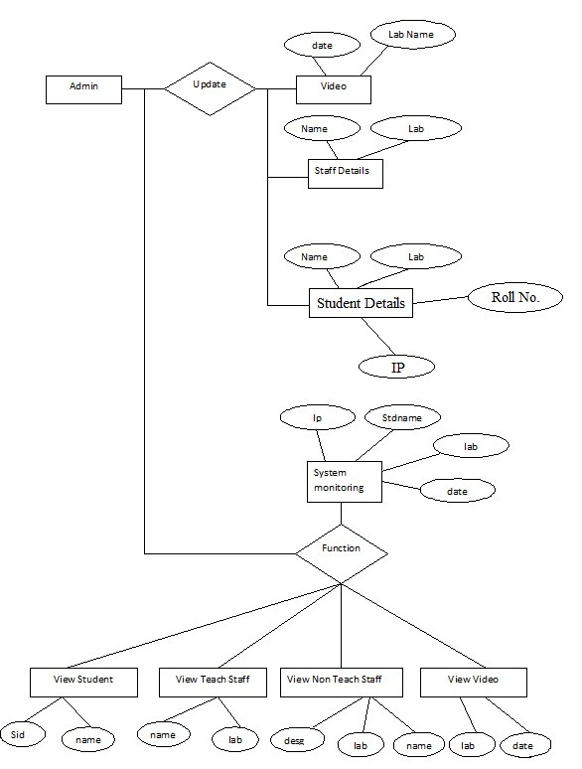

  - DATABASE DESIGN
Like other software engineering activities, data design (data architecting) creates a model of data and/or information that is represented in at a higher level of abstraction (the customer/user’s view of data). James Martin defines databases as “A collection of data designed to be used by different programs”. It can also be defined as a collection of interrelated data stored together with controlled redundancy to serve one or more application in an optional fashion. A database is a collection of interrelated data stored with minimum redundancy to serve users more quickly and efficiently. The general theme behind a database is to handle information as an integrated whole.
The general objective of a database is to make information access easy, quick, inexpensive, integrated and shared by different applications or users can access data through the database management system (DBMS). The data is stored so that they are independent of the programs that use them. A controlled common approach is used in inserting new data, modifying and retrieving existing data within the database. The data within an organization may be kept inside a computer for long time or more or less permanently. The software that allows one or more person to use and/or modify this data is termed as Database Management System (DBMS).

The main objectives covered in database design are:
- Controlled redundancy
- Data Independence
- Accuracy and Integrity
- Privacy and security
- Performance

  - Input Design

The user interface design is very important fir any application. The interface design defines how the software communicates with in itself, to system that interpreted with it and with human who use it. The interface design is very good; the user will fall into an interactive software application.

The input design is the process of converting the user-oriented inputs into the computer-based format. The data is fed into the system using simple interactive forms. The forms have been supplied with messages so that user can enter data with out facing any difficulty. The data is validated wherever it requires in the project. This ensures that only the correct data have been incorporated into the system.

The goal of designing input data is to make the automation as easy and free errors as possible. For providing a good input design for the application easy data input and selection features are adopted. The input design requirements such as friendliness, consistent format and interactive dialogue for giving the right message and help for the user at right time are also considered for the development of this project. Input design involves determining the record media, method of input, speed of capture and entry to the system.

The objectives of input design are:
- To produce a cost effective method of input.
- To make the input forms understandable to user.
- To ensure the validation of data input.
- To achieve the highest possible level of accuracy.

The various activities to be performed for the overall input process are:
- Data recording at its source.
- Data transfer to input form.
- Data conversion to computer acceptable mode.
- Data flow control.
- Data validation.
- Data correction if necessary.

  - Output Design
The objective of the output design is to convey the information of all the past activities, current status and emphasize important events. Computer output is the most important and direct source of information to the user. Efficient, intelligible output design should improve the system, relationships with the user and help in decision making. A major form of output is the hardcopy from the printer. The output generally refers to the results and information that is generated from the system. Outputs from the computers are required primarily to communicate the result of processing to the users. They are also used to provide a permanent copy of these results for later consideration. Reports of the project should be designed around the output requirements of the user.
Output also provides a means of storage by copying the results for later reference in consultation. There is a chance that some of the end-users will not actually operate the input data or information through workstations, but will use the output from the system.

Two phases of the output design are:
- Output definition.
- Output specification.

Output definition takes into account the type of output contents, its frequency and its volume the appropriate output media is determined for outputs. Once the output media is chosen, the detail specification of output documents are carried out.
The nature of output required from the proposed system is determined during logical design stage takes the outline of the output from the logical design and produces the output as specified during the logical design phase.

When designing the output, system analyst must accomplish the following:
- Determine the information to present.
- Decide, whether to display, print, speak the information and select the output medium.
- Arrange the information in acceptable format.
- Decide how to distribute the output to intended receipt.

Database Tables Used in Automated Monitoring System
login
Field | Type | Collation | Null | Default | Extra
id | int (10) | - | No | None | Auto_increment
username | varchar(100) | latin1_swedish_case_insensitive | No | None | -
password | varchar(100) | latin1_swedish_case_insensitive | No | None | -

staff_detail
Field | Type | Collation | Null | Default | Extra
id | int (10) | - | No | None | Auto_increment
Staff_name | varchar(100) | latin1_swedish_case_insensitive | No | None | -
desg | varchar(100) | latin1_swedish_case_insensitive | No | None | -
specialist | varchar(100) | latin1_swedish_case_insensitive | No | None | -
lab | varchar(100) | latin1_swedish_case_insensitive | No | None | -

std_details
Field | Type | Collation | Null | Default | Extra
id | int (10) | - | No | None | Auto_increment
r_no | varchar(100) | latin1_swedish_case_insensitive | No | None | -
class | int (50) | - | No | None | -
std_name | varchar(100) | latin1_swedish_case_insensitive | No | None | -
lab | varchar(100) | latin1_swedish_case_insensitive | No | None | -
ip | varchar(100) | latin1_swedish_case_insensitive | No | None | -
subject | varchar(100) | latin1_swedish_case_insensitive | No | None | -

sys_monitor
Field | Type | Collation | Null | Default | Extra
id | int (10) | - | No | None | Auto_increment
r_no | varchar(100) | latin1_swedish_case_insensitive | No | None | -
std_name | varchar(100) | latin1_swedish_case_insensitive | No | None | -
lab | varchar(100) | latin1_swedish_case_insensitive | No | None | -
ip | varchar(100) | latin1_swedish_case_insensitive | No | None | -

teach_staff_detail
Field | Type | Collation | Null | Default | Extra
id | int (10) | - | No | None | Auto_increment
Staff_name | varchar(100) | latin1_swedish_case_insensitive | No | None | -
desg | varchar(100) | latin1_swedish_case_insensitive | No | None | -
lab | varchar(100) | latin1_swedish_case_insensitive | No | None | -

timetables
Field | Type | Collation | Null | Default | Extra
pg1 | varchar(100) | latin1_swedish_case_insensitive | No | None | -
pg2 | varchar(100) | latin1_swedish_case_insensitive | No | None | -
MCA | varchar(100) | latin1_swedish_case_insensitive | No | None | -
MCA | varchar(100) | latin1_swedish_case_insensitive | No | None | -
mp | varchar(100) | latin1_swedish_case_insensitive | No | None | -
LIC | varchar(100) | latin1_swedish_case_insensitive | No | None | -
ADC | varchar(100) | latin1_swedish_case_insensitive | No | None | -
VLSI | varchar(100) | latin1_swedish_case_insensitive | No | None | -
DSP | varchar(100) | latin1_swedish_case_insensitive | No | None | -
CD | varchar(100) | latin1_swedish_case_insensitive | No | None | -
IC | varchar(100) | latin1_swedish_case_insensitive | No | None | -
video
Field | Type | Collation | Null | Default | Extra
id | int (10) | - | No | None | Auto_increment
day | varchar(100) | latin1_swedish_case_insensitive | No | None | -
video_date | varchar(100) | latin1_swedish_case_insensitive | No | None | -
video_name | varchar(100) | latin1_swedish_case_insensitive | No | None | -
lab | varchar(100) | latin1_swedish_case_insensitive | No | None | -
class_name | varchar(100) | latin1_swedish_case_insensitive | No | None | -

CHAPTER 6
SYSTEM TESTING
Software Testing is a critical element of software quality assurance and represents the ultimate review of specification, review and coding. The increasing visibility of software as a system element and the attendant “costs” associated with a software failure are motivating forces for well planned, through testing. Software testing fundamentals define the overriding objectives for software testing. Test case design focuses in a set of techniques for the creation of test cases that meet overall testing objectives.
Testing presents an interesting anomaly for software engineer. Earlier in the software process, the engineer attempts to build software from an abstract concept to tangible implementation. The engineer creates a series of test cases that are intended “demolish” the software that has been built. In fact, testing is the one step in software engineering process that could be viewed as destructive rather than constructive.
Software developers are by their nature constructive people. Testing requires that the developer discard preconceived notions of the “correctness” of the software just developed and overcome a conflict of interest that occurs when errors are uncovered. A testing and test case design is an admission of failure, which instils a goodly dose of guilt. And the tedium of testing is just punishment for our errors. Testing cannot show the absence of defects, it can only show that software errors are present.
Objective
The objective of software testing is to uncover errors. To fulfil this objective, a series of test steps-unit, integration, validation and system test- are planned and executed. Unit and Integration test concentrate on functional verification of the components and incorporation of components into a program structure. Validation testing demonstrates tractability to software requirements, and system testing validates software once it has been incorporated into large system. Each test step is accomplished through a series of systematic test techniques that assist in the design of test cases. With each testing step, the level of abstraction with which software is considered is broadened.

  - Unit Testing
Unit testing involves testing individual functions, or small clusters of functions. The purpose of unit testing is to thoroughly exercise individual functions to ensure high quality in their design and implementation. Unit testing is used to uncover defects that often do not appear in integration testing, as only a small subset of inputs and decision paths are used at this level.

  - Integration Testing
Integrated testing is a logical extension of unit testing. In its simplest form, to units that have already been testing is combined into component and the interface between them is tested. A component, is this sense, refers to an integrated aggregate of more than one unit.
Integration testing identifies problems that occur when units are combined. By using a test plan that requires you to test each unit and ensure the visibility of each before combining units are likely related to the interface between units.
The three common strategies of integration testing are top-down approach, bottom-up approach and umbrella approach.
Top-down approach : The high level modules are tested and integrated first.
Bottom-up approach : The lowest-level modules are tested are tested and integrated first.
Umbrella approach : The testing is done along functional data and control flow path. First, the inputs for function are in the bottom-up pattern. The outputs for each function are then integrated in the top-down manner.
  - White Box Testing
White box testing or implementing testing, is based on knowing the internals of the function. This allows the tester to write to write tests that exercise boundary conditions, conditional branches and state transitions. In white box testing, the tester should attempt to
- Test all branches of the method
- Test all boundary conditions in the method
- Test all possible combinations of state transitions
While useful and necessary to achieve code coverage, white box testing is limited. It can reveal defects in how the code handles branches, unusual input, boundary conditions etc. It can verify that the code works as build, but it cannot verify that the code what it is supposed to do.

  - Black Box Testing
Black box testing or responsibility based testing, is based on specification of the function. The tester examines the documentation about the responsibilities of the function, and writes tests to verify that the function does in fact, meet its responsibilities.
  - Validation Testing
In validation testing, the requirements established as a part of software requirements analysis are validated against the software that has been constructed. Validation testing provides final assurance that the software meets all functional, behavioural and performance requirements. After each validation test case has been done, one of the two possible conditions exists:
- The function or performance characteristics confirm to specification and are accepted.
- A deviation from specification is uncovered and a deficiency list is created.

  - Software Testing

Software testing is the process used to measure the quantity of developed computer software. Usually, quality is constrained to such topics as correctness, completeness, security, but can also include more technical requirements. Testing is a process of technical investigation, performed on behalf of stakeholders, that is intended to reveal quality-related information about the product with respect to the context in which it is intended to operate. This includes, but is not limited to, the process of executing a process of executing a program or application with the intent of finding errors. A common practice of software testing is that it is performed by an independent group of testers after the functionality is developed but before it is shipped to the customer.

  - Performance Testing

It covers a broad range of engineering or functional evaluations where a material, product, or system is not specified by detailed material or component specifications: Rather, emphasis is on the final measurable performance characteristics.

Test Cases

Sl. No. | Module | Test Condition | Expected Result | Result
1. | Login | Enter invalid username and password | Error message should be displayed | Success
2. | Login | Enter valid username and password | Allows to login | Success
3. | Select Lab | Select radio button | Lab selected | Success
4. | Date Picker | Select the date | Date Selected | Success
5. | Time Table | View recorded video, but not uploaded | Videos Not Available | Success
6. | Time Table | View recorded video, but uploaded | Videos Available | Success
7 | Time Table | View LIVE Videos | Informing using Alert box to click view video only | Success
8. | Time Table | Select Session | Options Visible  And run video | Success
9 | Student Monitoring | Enter Details | Saved to database | Success
10 | Student Monitoring | View details | Retrieve database | Success
11 | Student Monitoring | Modify details | Updated to database | Success
12 | Non Teaching Staff | Enter Details | Saved to database | Success
13 | Non Teaching Staff | View details | Retrieve database | Success
14 | Non Teaching Staff | Modify details | Updated to database | Success
15 | Teaching Staff | Enter Details | Saved to database | Success
16 | Teaching Staff | View details | Retrieve database | Success
17 | Teaching Staff | Modify details | Updated to database | Success
18 | Upload Video | Enter Details | Saved to database | Success
19 | Upload Video | View Videos | Retrieve  database | Success
20 | Settings | Change Password with invalid input | Error Message displayed | Success
21 | Settings | Change Password with valid input | Password Changed | Success
22 | Logout | Click on logout | System Logged out | Success

CHAPTER 7
SYSTEM IMPLEMENTATION

Implementation is the stage of the project when the theoretical design is turned into a working system. Implementation includes all those activities that take place to convert from the existing system to the new system. The new system may be totally new, replacing an existing system. It includes careful planning, investigation of current system and its constraints on implementation, design of methods to achieve the changeover, training of the staff in the changeover procedure and evaluation of changeover method.
The first task in implementation is planning-deciding on the methods and time-scale to be adopted. Once the planning has been completed, the major effort is to ensure that the programs in the system are working properly. At the same time concentrated on training the staff. When the staff s have been trained, the complete system, involving both computer and user can be executed effectively.
Implementation is used here to mean the process of converting a new or a revised system design into a Operational one. Conversion is one aspect of Implementation. Proper implementation is essential to provide a reliable system to meet the organizational requirements. Successful implementation may not guarantee improvement in the organization using the new system, as well as, improper installation will prevent any improvement.
The process of putting the developed system in actual use is called system implementation. This includes those activities that take pace to convert from old system to new system. The system can be implemented only after through testing is done and if it is found to be work according to the specifications. The system itself checks the feasibility of the system.

CHAPTER 8
CONCLUSION AND FUTURE ENHANCEMENTS

  - CONCLUSION

Automated Monitoring System deals with process of automating the environment as a whole. Here the pre-recorded and live streaming is done successfully. The final authority to make any alteration is the administrator alone.

The system has been successfully able to retrieve the contents from the database. The videos and individual details are being provided for the corresponding laboratory and session only.

  - FUTURE ENHANCEMENT

The designing of this system has been done in such a way that the addition of any new module, if necessary, is possible without affecting the integrity of the present system. This system can be further enhanced by providing direct retrieval of videos from the DVR hard disk.

The system uses some additional software such as PSS and CLASSROOM SPY. Currently the system downloads the executable file and hence it is run. This system can be further enhanced by achieving these software assistance by running them from the local disk itself.

CHAPTER 9

APPENDIX

  - SOURCE CODE

  - SCREEN SHOTS

CHAPTER 10

REFERENCE

